**Software System**

Hotel Management System For a Hotel

**Features**

Features are listed below.  **High**, **Medium** and **Low** are used to indicate the importance of each

feature.

|  |  |  |  |
| --- | --- | --- | --- |
| **Feature ID** | **Description** | **Priority** | **Requester** |
| **FE01** Employee Management | Employee management module will include all operations related to employee accounts – creation, deletion, edits, search and so on. | High |  |
| **FE02** Customer Management | Employee management fetcher will include all operations related to employee accounts – creation, deletion, edits, search and so on. | High |  |
| **FE03** Booking | This fetcher will help book rooms for the customers | High |  |
| **FE04** Checkout | This fetcher will help people to checkout from the hotel | high |  |
| **FE05**  Food order | This fetcher will help people to order food | High |  |
|  |  |  |  |

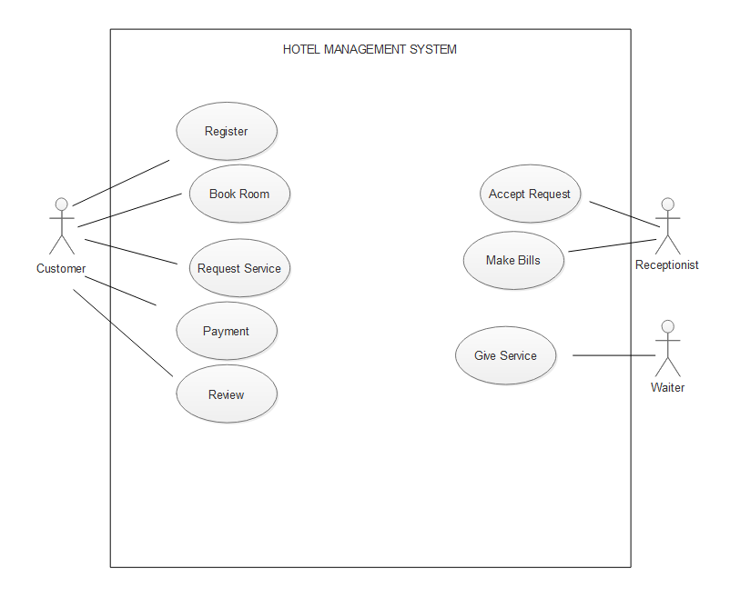

**Use Cases**

|  |  |
| --- | --- |
| **FE02 – User log in** | |
| **FE02_UC01** – Login | |
| **Brief Description** | User have to login to this system |
| **Pre-condition/s** | * User is not logged in already * User has an account in the system |
| **Priority** | High |
| **Actor/s** | Users of all classes. |
| **Main Success Scenario** | 1. User opens up the portal 2. The system displays a login form 3. User enters his/her user id and password 4. The system matches user credentials against its date store 5. The system then redirects user to the appropriate page based on user class. |
| **Alternative Scenario** | * The system cannot find a match for the user and re-displays the login form with an error message. * The system runs into internal error (i.e. database unavailable) and notifies user and asks the user to contact administrator |
| **Notes/Questions** | Must need clarification on dashboard for each user type. |

|  |  |
| --- | --- |
| **FE03 – Room Booking** | |
| **FE03_UC2** – Book room | |
| **Brief Description** | User wants to Book a room in the hotel |
| **Pre-condition/s** | * User must be logged in |
| **Priority** | High |
| **Actor/s** | Customer |
| **Main Success Scenario** | 1. The system displays a form with all the necessary fields required to collect customer information. These fields will be Name, Date of Birth, Present Address, Permanent Address, E-mail Id, Contact Number, The system automatically generates an Customer ID to the new customer 2. Authentication for email. 3. Authentication for contact number. 4. When all the information is put the system generates a successful operation message and updates all the information properly in the database. |
| **Alternative Scenario** | * The system is unable to store the information in database and generates operation not complete message. |
| **Notes/Questions** | The system will not store information from incomplete form. A form will be incomplete when all the ‘must be filled’ fields are not filled. |
|  | |
| **FE04_UC03** – Request Service | |
| **Brief Description** | The customer will request for a service |
| **Priority** | High |
| **Actor/s** | Customer |
| **Main Success Scenario** | 1. The user can fill a form for service request |
| **Alternative Scenario** | * If the form is incomplete system will reject the request |
| **Notes/Questions** | The form should contain correct information and verification. |

|  |  |
| --- | --- |
| **FE05_UC04** – Payment | |
| **Brief Description** | After certain service customer have to pay for the service |
| **Priority** | High |
| **Actor/s** | Customer |
| **Main Success Scenario** | 1. User have to pays who different payment method |
| **Alternative Scenario** | * The payment is not accepted |
| **Notes/Questions** | The payment procedure must be followed stickily |

|  |  |
| --- | --- |
| **FE06_UC05** – Review | |
| **Brief Description** | After the service customer may have to review for the service |
| **Priority** | Low |
| **Actor/s** | Customer |
| **Main Success Scenario** | 1. There will be a feedback form customer have to fill that form(optional) |
| **Alternative Scenario** | * Optional |
| **Notes/Questions** |

|  |  |
| --- | --- |
| **FE07_UC06** –Accept Request | |
| **Brief Description** | Receptionist will accept request form the customer |
| **Priority** | High |
| **Actor/s** | Receptionist |
| **Main Success Scenario** | . Receptionist will check the list form customer service list and Receptionist will accept the request |
| **Alternative Scenario** | * The request is rejected |
| **Notes/Questions** | The request form must verify carefully |

|  |  |
| --- | --- |
| **FE08_UC07** – Make bill | |
| **Brief Description** | After all the service all the service Receptionist will make the bill for customer |
| **Priority** | High |
| **Actor/s** | Receptionist |
| **Main Success Scenario** | . Receptionist will check the list form customer service list and all the activity’s form the customer then Receptionist will make the bill |
| **Alternative Scenario** | * Unable to make the bill for the lack of information |
| **Notes/Questions** | The bill should make verify carefully |

|  |  |
| --- | --- |
| **FE08_UC07** – Give service | |
| **Brief Description** | Waiter will provide the service for the customer requested |
| **Priority** | High |
| **Actor/s** | Waiter |
| **Main Success Scenario** | . waiter will check customer required list and do the service |
| **Alternative Scenario** | * Unable to provide the service |
| **Notes/Questions** |

**Non-Functional requirements**

**1.** Availability

**2.** Reliability

**3.** Data Integrity

**4**. Optimized